###### *Athabasca University* PHYS 204 Assignment 3

# Assignment 3

The ten questions below cover Units 8-10 and each carries equal weight. You are expected to solve all questions in detail and submit by uploading to the appropriate drop box. Scanned copy of your handwritten solutions should be acceptable.

1. A pump draws 750 kg of water per minute from a well 15.0 m deep and ejects it with a speed of 25.0 m/s, making a vertical fountain.
2. What is the power output of the pump?
3. How high is the fountain? Ignore air resistance.
4. The spring shown below has a spring constant equal to 1,500 N/m. It is compressed   
   18.0 cm, then launches a 400 g block. The horizontal surface is frictionless and the coefficient of kinetic friction with the incline is 0.15. What horizontal distance *d* does the block cover while in the air after it takes off at the top of the incline?

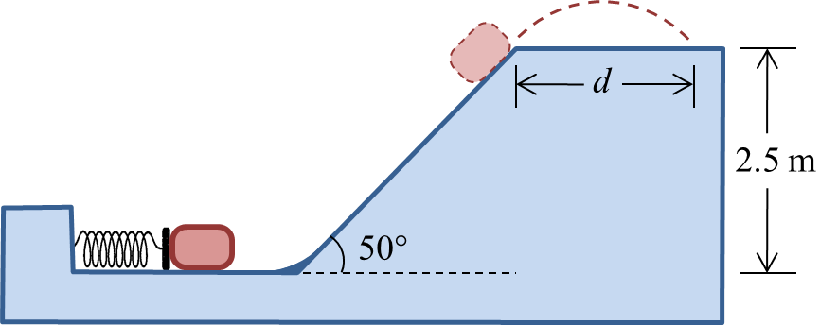

1. A locomotive with power capability of 1.5 MW accelerates a train steadily from a speed of   
   20 km/h to 50 km/h in 5.0 min. Calculate:
2. the distance travelled by the train during this time interval
3. the mass of the train
4. A uniform chain with a mass of 5.00 kg and a length of 2.00 m lies on a table with 50.0 cm hanging over the edge. What is the minimum energy required to get all of the chain back on the table?
5. A 12.0 g bullet moving with upward speed of 960 m/s strikes and passes through a 2.00 kg block initially at rest, as shown. The bullet emerges from the block with a speed of 240 m/s. To what maximum height will the block rise above its initial position?



1. A 3.00 kg object moving at 5.00 m/s strikes a 2.00 kg object initially at rest. Immediately after the collision, the heavier object has a velocity of 3.50 m/s directed 33.0°◦ from its initial direction of motion.
2. What is the speed of the other object?
3. Is this collision elastic or inelastic? Explain.
4. Two identical spheres, labeled *A* and *B*, collide. The initial velocities before the collision are ${\vec{v}}_{Ai}=\left(10.0 \hat{i}-15.0 \hat{j}\right) m/s$ and ${\vec{v}}_{Bi}=\left(12.0 \hat{i}-18.0 \hat{j}\right) m/s$. After the collision, sphere *A* moves with final velocity of ${\vec{v}}_{Af}=\left(8.00 \hat{i}-11.0 \hat{j}\right) m/s$. Determine the ﬁnal velocity of sphere *B*?
5. A 7.0 kg block is connected, as shown, by a light cord to a 3.0 kg mass, which slides on a rough surface with the coefficient of kinetic friction equal to 0.35. The pulley is a uniform disk of mass 1.0 kg and rotates about a frictionless axis. The cord does not slip on the pulley. Calculate:
6. the linear acceleration of the system.
7. the tension in the two sections of the cord.



1. A 2.5 kg solid block has the dimensions *a* = 12 cm, *b* = 20 cm and *c* = 2.0 cm. Calculate its moment of inertia about an axis through one corner and perpendicular to the large faces, as shown.



1. Calculate the moment of inertia of a solid cone about an axis through its centre. The cone has a mass *M* and height *h,* and the radius of its circular base is *R*.

